# Experiment #4 – Output Stages

**Last update: 2018A**

**01.10.17**

## Objectives

Acquainting yourselves with basic power amplifiers (class A, B, AB), crossover distortion, harmonic distortion, equations to calculate an amp’s power, and seeing how the amp’s temperature affects its power dissipation.

Maximum time allotted for this experiment: 4 hours.

## Recommended sources

1. Sedra Adel, S. Kenneth, C. Smith. Microelectronic Circuits, 6th Ed., New York, Oxford. Chap 11.
2. Millman, C., C. Halkias. Integrated Electronics Chap 18.
3. Datasheet: 2N1711, 2N2905

## Mandatory reading/viewing (files available on our Moodle website)

1. “INFOBIT – The XY mode”
2. Lecture 11 from Prof. Arie Ruzin’s “Analog Circuits” course (Power Stages)

## Your personal tour guide

* In your preparatory report, you will analyze the circuits used in the experiment.
* The purpose of the purple text is to give you an overview of what you’re doing – why are you analyzing this circuit? How does it relate to the other circuits? What is the purpose?
* In some of the following sections you will be required to choose numerical values for hand-calculations or simulations. If you have a lab partner, the last three digits of yours and your partner’s ID number will hence be referred to as “ABC” and “DEF”, respectively. If you are attending the lab alone, use your last six digits, i.e. “ABCDEF”.

Some notes on special considerations in circuit analysis of output stages

|  |  |  |
| --- | --- | --- |
|  |  |  |
| Figure 1 | Figure 2 | Figure 3 |
| For the above circuits, all transistors are matched,  large, , and:  , , , , . | | |

* When analyzing output stages, we have to remember that we’re usually dealing with large rather than small signal analysis. Remember what “small signal” analysis is? Recall that in the first few lectures in Analog Circuits, you assumed that a transistor is operating with a constant (DC) current , and that an input signal applies a very small change onto it, . Up until now, we always assumed , so we could separate these two components and define a “bias point”, then find the “small signal parameters”, such as  and .
* The trick to remember with output stages is that we cannot make the distinction between  and  anymore, but must use the combined, more general definition, “”. In the same way, we don’t usually won’t work with DC and AC voltages  and , but the combined voltage “”. Notation is important in output stages, so pay attention!
* How does this affect our analysis? To begin with, our “small signal parameters” are not constant anymore. Let’s understand this by analyzing Figure 3:

Some definitions and observations:

1. The transistors’ currents are, as usual, exponential to the BE voltage: .
2. The “Quiescent current” is the transistors’ currents with zero output:  
   .
3. From the above, note that  dictates the size of the quiescent current and the corresponding quiescent power dissipation (when the input is off).
4. A useful relationship between the above current can be found if we note that, and thus .
5. We may also perform KCL on the output node and write down quadratic equations for the currents:

|  |  |
| --- | --- |
|  |  |
| (a) | (b) |
| KCL: | KCL: |
| Figure 4 | |

Why is this result important?

* It gives us a solution (or two, due to symmetry) to the current through each transistor as a function of the quiescent and load currents.
* It implies that the transistor currents are complementary, so that when  rises,  diminishes, while keeping a constant product ().
* It means that if such an output stage has quiescent current , under this model we will always have both transistors conducting, though at certain times one may have exponentially low current.
* For the following answers to sections ‎1.1 to ‎1.9, you are allotted **1 line per section**! (i.e. total of 11 lines). This restriction also applies to your answers in sections ‎2 and ‎3.

1. For the circuit in Figure 1,
   1. Which class is this?
   2. Given the input , draw one period of both input and output signals as a function of the parameter , on the same graph.
   3. Qualitatively explain what happens in the positive half of  and the negative half of . Which transistors are operating, and when? What are the currents’ directions? (up to 2 lines for this answer).
   4. *Qualitatively* draw the transfer characteristic curve ; mark and calculate important points and the slope.
   5. Calculate the power dissipated in Q1 under quiescent conditions, .
   6. Calculate the average power dissipated in Q1, , assuming a sinusoid output voltage  of maximum possible amplitude, , where the circuit still operates linearly. Also find  the power delivered to, or dissipated in, the load.
   7. Calculate the average supply power, , for a sinusoidal input.
   8. Calculate the power-conversion efficiency, . What is  for this class?
   9. Calculate the average power dissipation in the circuit, . Find  and  for which ; also find  and  for which .
2. For the circuit in Figure 2, repeat the subsections of section ‎1.
3. For the circuit in Figure 3, repeat the subsections of section ‎1.

* Looking back at your answers, what’s the difference between a “really bad” class AB and a class B output stage? According to Sedra & Smith, and our course “Analog Circuits”, an output stage is defined as class B ***if and only if VBB=0***, i.e. the voltage difference between the transistor’s bases is identically zero.

1. Using your ID numbers, if (ABC>DEF) choose Figure 2, otherwise, choose Figure 3. Redraw the circuit with a single supply (V- grounded). Why is it beneficial, in this case, to have the load capacitive coupled (i.e. add a large capacitor at the output in series to )?
2. Let’s talk a little bit about the output resistance and voltage gain of output stages:

* The output resistance of the circuits above is approximately  for Figure 1 and  for Figure 2. BUT remember that these small signal parameters are now longer constant.
  1. Show that for Figure 1  for Figure 2 and Figure 3 .
  2. What is the output resistance of each of the three figures when ? In your answer, refer to the case .
  3. Qualitatively, how would the output resistance change for each of the three figures when  rises from zero to a higher value?
* Effectively, the dependence of the output resistance on the currents, which in turn depend on the input voltage, affects the voltage gain of the output stage. In other words, if the output resistance continuously changes, it means *the voltage gain is not linear* (though under normal conditions this nonlinearity may be negligible).
* We could find the DC voltage gain  using some KVL, KCL, and the quadratic equation we found above. However, to assess the linearity of the voltage gain, all we need is the *incremental voltage gain* , which is calculated for a specific value of the continuously changing . Using a Thevenin representation, it is simply expressed as:



* 1. Qualitatively, how would the incremental gain change for each of the three figures when  rises from zero to a higher value? Explain how this implies that the circuit voltage gain is not linear.

1. How-to: measuring output stages in the lab

* Since calculations could be quite cumbersome, we will make the following assumptions and approximations:
  + The power supplied by the waveform generator is always negligible.
  + When the output is oscillating, the positive power supply (V+) supplies power for a complete half-period (i.e. for  radians), disregarding crossover or other kinds of distortion.
  + The power supplied by the positive (V+) and negative (V-) power supplies is equal, due to symmetry (in most circuits).
* In the experiment, you will measure the peak to peak voltage  across the  resistors. According to the above assumptions, you will approximate the *average current* drawn from the voltage supplies over *half a period*, , of a sine waveform:



* 1. Observe Figure 5. To measure  as described above, you will simply measure VPP on TP24 with the scope. Recall that the scope measures the potential difference from the measured test point relative to the ground. In one line, explain: why is this measurement equivalent to directly measuring the peak-to-peak voltage across the  resistor?
* If the circuit operates with small load resistors, the DC power supplied would be negligible in comparison. This is nearly always the case in the experiment, which is why almost always  and can be **neglected**. Read more below.
* Still, you might be asked to consider it, by again calculating the current on the  resistors, this time with no input signal ():



* 1. Observe Figure 5. To measure  as described above, you will make two measurements: one on TP24, and the other of V+ by very carefully touching the left node of the  resistor. Subtracting the two measurements will give you . Which of the following scope measurements are relevant for this calculation? AC-RMS, DC-RMS, VPP, MEAN, MIN, MAX. Explain.
* If the circuit employs small load resistors, and the current flow throughout the cycle is known, it might still be possible to deduce  directly from measurement of the load:
  1. Observe Figure 5. Rewrite the formula for  assuming you only have the value of  and that it is small enough, and a VPP measurement of  from the scope.
* The sum of the current supplied would be .
  1. Describe a formula that calculates the total average power supplied by the power supplies . Hint: you could separately find the power supplied through  using , and the power supplied through  using .
  2. Following are two formulas for calculating the average power dissipated on a load   
     resistor : , .
     1. Show how to get to each of these formulas assuming  where  is the amplitude of the measured sine signal.
     2. For which waveforms are these expressions correct? How would you calculate  for an arbitrary, periodic waveform?
* In the following circuits, and the experiment, .
* Where required, assume  and .
* For simulation purposes, use the following models:
  + NPNs: Q2N2222
  + PNPs: Q2N2907A
  + Diodes: D1N914
  + Op-amp: uA741

1. Output stage with biasing resistors

Refer to the experimental procedure, section ‎2.

Consider the following circuit from the experiment:



Figure 5

**In this section, assume the output is loaded with .**

* 1. *Qualitatively* draw the output voltage as a function of time, assuming an input .
  2. Explain what happens in the positive half-cycle of the input signal, and in the negative half-cycle. Explain the operating regime of the transistors and the currents through them.
  3. Which class is this?
  4. Calculate  for this circuit. Define the term “crossover distortion”.

1. Output stage with biasing diodes

Refer to the experimental procedure, section ‎3.

Consider the following circuit from the experiment:



Figure 6

**In this section, assume the output is loaded with .**

* 1. *Qualitatively* draw the output voltage as a function of time, assuming an input .
  2. Explain what happens in the positive half-cycle of the input signal, and in the negative half-cycle. Explain the operating regime of the transistors and the currents through them.
  3. Which class is this?
  4. Is there crossover distortion in this circuit? Explain what happens when  crosses 0V.
  5. Estimate symbolically the input resistance when . Then, plug in numbers and give a numerical result.
  6. For an input , estimate the efficiency of this circuit, .

1. Output stage with biasing transistors

Refer to the experimental procedure, section ‎4.

Consider the following circuit from the experiment:



Figure 7

**In this section, assume the output is loaded with .**

* 1. *Qualitatively* draw the output voltage as a function of time, assuming an input .
  2. Explain what happens in the positive half-cycle of the input signal, and in the negative half-cycle. Explain the operating regime of the transistors and the currents through them.
  3. Which class is this?
  4. Estimate symbolically the input resistance when . Then, plug in numbers and give a numerical result.
  5. Explain what Q17 and Q18 are good for (why not use diodes as in Figure 6?).
* Observe the following modification:



Figure 8

* 1. Connecting QX to Q16 (and a complementary one to Q19), will have the positive advantage of *overcurrent protection*. Explain how overcurrent circuit protection works (review Experiment 3: Regulated Power Supplies).

1. Output stage with feedback

Refer to the experimental procedure, section ‎5.

Consider the following circuit from the experiment:

TP6

TP9

TP8

TP7

0

Q2

Q3

R7

22

R10

22

R13

18k

R5

18k

R78

5

R15

5

R12

1k

R9

220

C11

22u

V-

V+

Q1

Q4

R6

22

R14

22

R8

22

R11

22

Figure 9

* Note that the output is connected to the emitters of Q2 and Q3, marked with a green dashed ellipse.
  1. Suppose that the circled connection was **not made**. Dismissing the effects on the behavior of the circuit in this case, *qualitatively* estimate the circuit’s output resistance.
* In order to work out what’s happening in this circuit, we have to turn to *feedback theory*.
* The above circuit may be schematically described as follows:



Figure 10

* The amplifiers Q2 and Q3, here depicted by triangles, are called ***error amplifiers***.
* Let us inspect the behavior of the circuit in one half-cycle. The feedback topology may be deduced from the following schematics ():

|  |  |  |
| --- | --- | --- |
|  |  |  |
| Equivalent half-circuit | Feedback circuit | Loaded open-loop half-circuit |
| Figure 11 | Figure 12 | Figure 13 |

* One may deduce that the feedback topology is series-shunt, i.e. voltage sampling and voltage mixing. The feedback factor is thus,



* The feedback circuit is given in Figure 12. Note that calculating the loading effects, we easily find that  and .
* Hence, the open-loop half-circuit, including the feedback’s loading effects, is depicted in Figure 13. The feedback-loaded open-loop gain is



* One can now easily find the approximate closed-loop output resistance of the half-circuit in Figure 11.
  1. Using the above derivation, symbolically find the closed-loop output resistance of the half-circuit in Figure 11. What is the output resistance of the entire circuit (Figure 9)? Compare to section ‎10.1.
* The feedback loop doesn’t reduce the crossover distortion. Instead, it provides better linearity of the output vs. input in large voltage swings.
  1. In Sedra & Smith 6th Ed., Chap. 11, section 11.6 (pg.937), it is said,

“Also, observe that if the loop gain is large, the voltage difference between the two input terminals of each feedback amplifier, the error voltage, will be small, resulting in .”

In 2-3 lines, qualitatively explain this claim. How does this relate to the linearity of the circuit (recall section ‎5)?

* 1. Calculate  for this circuit. How much more voltage is required between the transistors’ bases so as to eliminate crossover distortion completely?
  2. *Qualitatively* draw the output voltage as a function of time, assuming an input .
  3. Explain what happens in the positive half-cycle of the input signal, and in the negative half-cycle. Explain the operating regime of the transistors and the currents through them.
  4. Which class is this?

1. Output stage op-amp feedback

Refer to the experimental procedure, section ‎6.

Consider the following circuit from the experiment:



Figure 14

* Note that this is essentially the same circuit as in Figure 9, with two changes: an op-amp feedback network, and a bunch of capacitors (C19-C24). Everything we discussed in section ‎10, including the implicit feedback, is still relevant.
* This circuit may therefore be schematically depicted as follows:



Figure 15

**In this section, the output is not loaded.**

* 1. Assume that the op-amp has a finite gain , but is otherwise ideal, and that Figure 9 has approximately unity voltage gain. Find the gain, vout/vg.
  2. In section ‎10.4 you showed that in the “dead-band”, where the transistors are in the cutoff regime, crossover distortion dominates. Explain how this circuit compensates for it and estimate the new, reduced, dead-band.
* **In the following two simulations make sure you select “*Skip the initial transient bias point calculation (SKIPBP)*” in Simulation Settings!**
  1. Simulate this circuit in PSPICE (without the capacitors C19-C24). Attach a print of the circuit and a graph of vg, vop, and vout, for an input sine/1kHz/0.5Vpp. Show one period.
  2. Simulate the circuit again, this time with an equivalent capacitor of **500nF** connected between the bases of Q5 and Q8.
  3. Qualitatively explain what happens to the op-amp in the crossover region, and how do the capacitors help.
* Note that in the experiment, the maximum capacitance is **555pF**, which is three orders of magnitude smaller than what you simulated here.

1. Amplifier with output stage

Refer to the experimental procedure, section ‎7.

Consider the following circuit from the experiment:

**B**

0

Q10

Q9

Q12

R35

110

Q13

R32

130

R31

1.8k

R39

360

R40

360

V+

R30

5

R38

2.2k

C13

220u

R37

1k

V-

C15

47u

R74

50k

Q11

0

V-

0

R36

4.7

V-

R34

18k

R33

100

C14

220u

0

TP50

TP15

TP19

TP17

TP16

**C**

**A**

Figure 16

**In this section, assume  and** **.**

* 1. The subcircuit marked “**A**” is a current mirror.
     1. Calculate the current pulled by this mirror, .
     2. Derive symbolically the output resistance seen into the collector of Q12 (assume  is finite).
  2. The subcircuit marked “**B**” is an output stage.
     1. Which class is this?
     2. Regarding this subcircuit only, explain what happens in the positive half-cycle of the input signal, and in the negative half-cycle. Explain the operating regime of the transistors and the currents through them.
     3. Why is the capacitor C13 required here?
  3. The subcircuit marked “**C**” is an amplifier.
     1. Which amplifier is this?
     2. Calculate the small signal voltage gain of this amplifier, , in intermediate frequencies. Does the resistance calculated in section ‎12.1.2 affect this gain?
     3. Why were the values of R74 and R34 chosen this way?
  4. Estimate the total voltage gain of this circuit, with TP15 the input of the circuit.

1. THD and spectrum measurement

* In the experiment you will have to use the scope’s FFT function to display and measure the spectral content of a signal. Read “INFOBIT – How to measure a spectrum” on our lab’s website and answer the following questions.
  1. Given a square wave with base frequency AB kHz, what would the Span be in order to have the first 5-10 harmonics displayed on screen? What would be considered a “good FFT resolution” in this case?
  2. Denoting the harmonics of a spectrum , where  is the first harmonic, the scope will measure these in dBV, i.e. .. Setting the scope correctly, you will be able to measure the harmonics in dB. Explain the difference and explain how you would do this using the scope.
* Once you have the values of the harmonics in dB, you’ll be able to calculate the total harmonic distortion, or THD. If you measured all harmonics relative to the first harmonic, then the formula would be,



where  is the measurement of the mth harmonic from the scope.

* 1. Suppose you have a square wave input between -1V and 1V, and you take its spectrum using the scope. Explain how would the spectrum look like for a duty cycle of 50%, and for a duty cycle of 33.33%.
  2. Which 5 harmonics would you measure to estimate the THD of the signal from ‎13.3?

1. Thermal calculations
   1. Define the following: .
   2. Using the datasheet of transistor model 2N2905 (use the one on the course website), find . Then, calculate the following (each subsection is independent of the others; use only the given data):
      1. , assuming , 
      2. , assuming , 
      3. , assuming , 

* The resistors R56,R57 in Figure 7 and similar ones in the other circuits, compensate between mismatches in Q16,Q19, and could also protect these transistors from “*thermal runaway”*, where a transistor (or a localized part of it) heats up quickly. Due to this heating and through a form of positive feedback, the transistor’s temperature keeps rising until it is ultimately destroyed.
  1. Assuming thermal runaway happens at , and , what is the requirement on  so that the junction isn’t destroyed?

# Experimental procedure

|  |  |  |  |
| --- | --- | --- | --- |
|  |  |  |  |
|  |  |
| **Booth number** | **Board number** | **Student IDs** | **Your names** |

Reminder:

1. **All the answers for the practical and theoretical questions shall be written down in this document, during lab hours only.**
2. **Save this file as “report4_XXX_YYY” when XXX, YYY are your students ID’s. Please save this document right now as to avoid any future inconvenience.**
3. **At the end of this lab you must upload this file under the right assignment to the course site and click “hand in assignment”:**

**• If you have yet to complete this experiment in its entirety, please upload the file under the “Progress report” assignment.**

**• If you had completed this experiment and answered all of the questions, please upload the file under the “Post lab (Final)” assignment.**

1. **You cannot “fix” sections that have been answered without a special approval from your lab instructors.**
2. **You should not attempt to upload or send the assignments from your home or after/before lab hours.**
3. Mandatory preparation

* 1. First, read the following and answer the questions therein:

**Important safety instructions – MANDATORY READING**

* This board has **6** sub-circuits - output stages - installed on it. Each sub-circuit will use a specific load resistance, which is comprised of the 1kΩ resistor already connected plus Rx or Ry in parallel, as instructed. Do NOT connect Rx and Ry together, or any other load resistance unless explicitly instructed!
* Assume we have a 10Vpp sine signal on a 33Ω resistor. What would be the maximal and RMS current flowing through it?

|  |  |
| --- | --- |
| Imax= |  |
| IRMS= |  |

* The conclusion from this calculation is that the expected currents in this experiment are much higher than in other experiments. Therefore, it is very important to pay attention to the current being drawn from the power supplies at any given time, and **make sure it does not exceed the safety limit of 80mA**.
* Right now, when there is nothing connected to the circuit, write down the currents drawn from the power supplies at this moment. You will find them on the second line on the board’s base, e.g.:

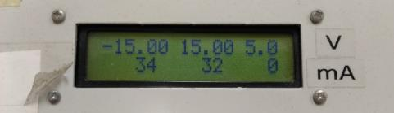

|  |  |
| --- | --- |
| IPS+= |  |
| IPS-= |  |

* **If you notice currents in excess of the safety limit 80mA, SHUT DOWN THE BOARD IMMEDIATELY**, and check:
  + Has anything been short-circuited?
  + Did you connect a load resistance smaller than instructed?
  + Did you short-circuit the sub-circuit’s output the **ground?!**
  + Is your input (and as a result, output) signal’s amplitude too large?

If this problem persists, call the lab instructor for assistance.

* 1. Measuring Rx and Ry
     1. **Make sure nothing is connected to the board**, and that the board’s base is on.
     2. Use a BNC cable to connect the multimeter to “CH1” on the top left of the board.
     3. Connect a wire from TP1 to TP41 to measure Rx.
     4. Press the “Ω2” button on the multimeter and measure Rx’s resistance.
     5. Switch the wire from TP42 to measure Ry.
     6. Measure Ry’s resistance.
     7. **Now, press the “DCV” button on the multimeter**, and write down the resistance values you just measured:

|  |  |
| --- | --- |
| RX= |  |
| RY= |  |

* + 1. Disconnect the wire from the board.
    2. Disconnect the multimeter from the board.
* Important note #1: NEVER PERFORM A DIRECT RESISTANCE MEASUREMENT such as the one you’ve just done (“Ω2” or “Ω4” in the multimeter), unless explicitly instructed. You may inadvertently damage the multimeter!
  1. Measuring the power supplies’ voltages and currents
     1. Set the voltage supplies to +/-15V. Write down the values below.

|  |  |
| --- | --- |
| Positive power supply, V+= |  |
| Negative power supply, V-= |  |

* If you cannot reach +/-15V, make sure V+=|V-| and closest to 15V as possible.
  + 1. According to your answers in the preliminary report, shortly explain (up to 5 lines) here how you would measure the current drawn from the positive power supply of the output stage with biasing diodes. Mention in an example appropriate TP nodes, measuring device, type of measurement, and calculation.

|  |
| --- |
|  |
|  |
|  |
|  |
|  |

* Important note #2: in this circuit you’ll many times be asked to “measure” or “calculate” a current through some resistor, or circuit. NEVER PERFORM A DIRECT CURRENT MEASUREMENT (“IAC” or “IDC” in the multimeter). Review the preliminary report now to understand how to correctly calculate currents from voltage measurements.
  1. Safety reminder

The board contains many metallic parts, some of which with relatively **high voltage** and the ability to conduct **high current**. This means you may very easily burn things or in some extreme cases even get electrocuted.

**NEVER “throw” wires around on the board, or leave a wire unattached!**

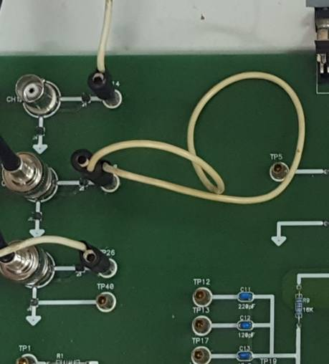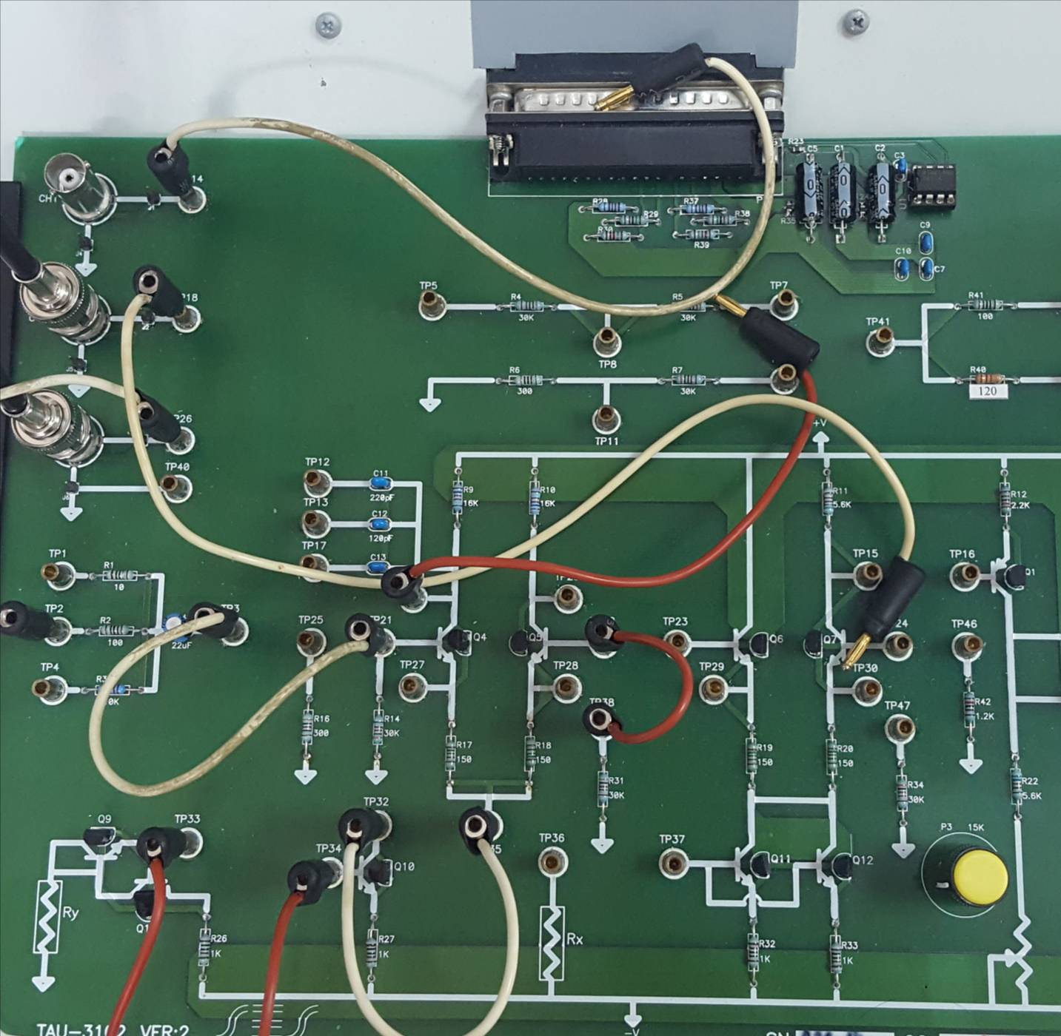

Figure 17

1. Output stage with biasing resistors

Refer to the preliminary report, section ‎7.

* 1. Write down your ID numbers here, and add them together:

|  |  |
| --- | --- |
| ID#1 |  |
| ID#2 |  |
| ID#1+ID#2 |  |
| Is the sum an even number? |  |

If the sum ID#1+ID#2 is an even number, load this circuit with resistor RX. Otherwise, load it with resistor RY.Which resistor did you connect here?

|  |
| --- |
|  |

* 1. Connect an input signal: sine/1kHz, and choose its amplitude such that the **output** of the circuit measures **8Vpp**. Make sure the currents drawn from the power supplies are within the safety limit. What is the equivalent load resistor seen by this output stage? What is the input voltage you used?

|  |
| --- |
|  |
|  |

IMPORTANT: recall now your answers from section ‎6 in the preliminary report.

* 1. Efficiency calculation
* In the following section you will try to measure the **DC current** drawn from the positive power supply, . Theoretically, you know what to do. But practically, is it easy to do? Is it even possible to accurately measure this current??
  + 1. Configure the scope and waveform generator such that you can perform an accurate measurement to deduce  from (you must understand what to do on your own).
    2. Connect the scope’s CH1 to the test point (TP) to the right of the 5Ω resistor.
    3. Use CH2 to carefully touch the left lead of the resistor, as shown in the next figure:

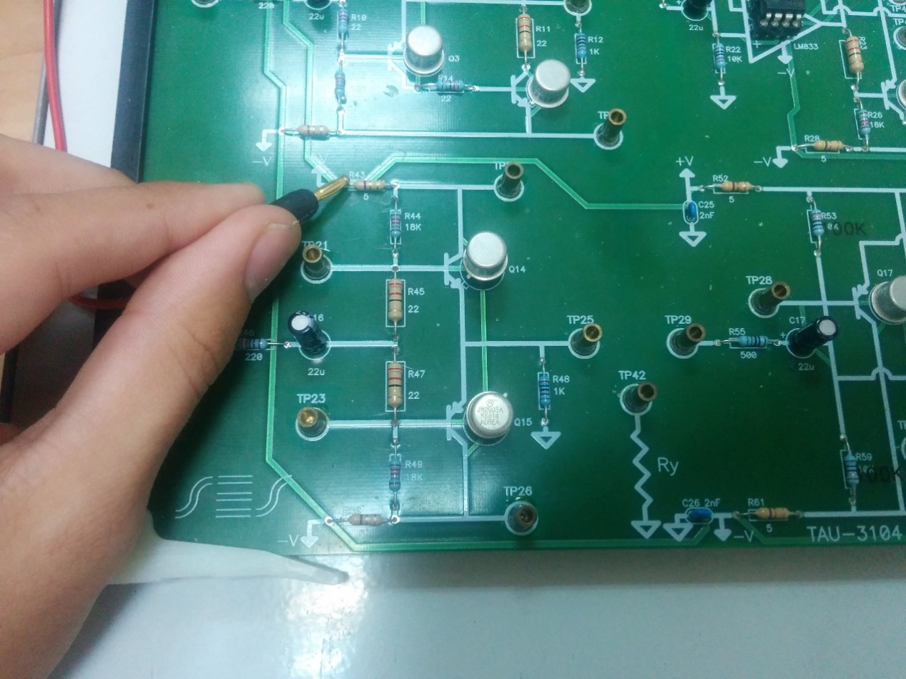

* + 1. Attach a print with DC RMS and Average (Full Screen) measurements for each channel (total of 4 measurements), and use each to calculate .

*Print: for calculating *

|  |  |
| --- | --- |
| 5Ω resistor, right lead |  |
| 5Ω resistor, left lead |  |
|  | |

|  |  |
| --- | --- |
| 5Ω resistor, right lead |  |
| 5Ω resistor, left lead |  |
|  | |

* + 1. Now use the multimeter and measure both leads as above, then calculate . Make sure you set the multimeter to measure in the highest resolution, by pressing the “Resolution” or “DIGITS” buttons, depending on your device:

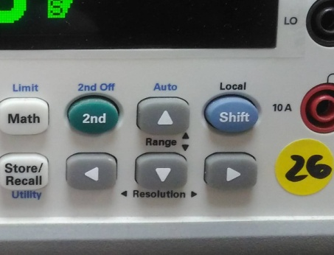 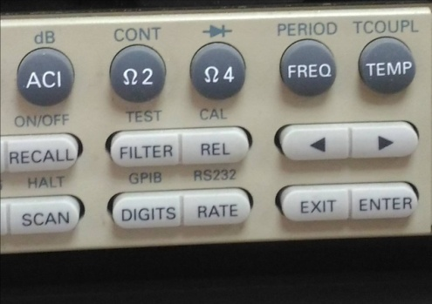

|  |  |
| --- | --- |
| 5Ω resistor, right lead |  |
| 5Ω resistor, left lead |  |
|  | |

* + 1. What is the theoretically expected ? Perform a calculation using the values you measured in ‎1.3.1.

|  |
| --- |
|  |

* Discuss amongst yourselves: which device is more accurate? Why? Which device would you use to measure this current? Does it matter? (no need to write an answer!)
* A note about noise: in Experiment #1: Operational Amplifiers, you were taught that we place a limit on measurement accuracy to 50mV, due to noise. The circuitry there involved active components (op-amps), complex feedback circuitry, and the waveform generator’s signal.   
  Here, we have a very simple case: measuring voltage of one resistor with a (well-regulated) DC supply source. Therefore, our noise limitation is much diminished, and we can reliably measure voltage variations in the 1mV range.
  + 1. Attach a print with Vpp and frequency for the input signal, and Vpp and RMS for the output signal (total of 4 measurements). Then, calculate the power dissipated on the load, .

*Print: input and output*

|  |
| --- |
|  |

* + 1. Using this input, attach a print with appropriate measurements and use it to calculate .

*Print: for calculating .*

* + 1. Calculate  and . Then find the efficiency of this stage, .

|  |
| --- |
|  |
|  |
|  |

In the following section, you will make some changes to the circuit which may results in supply currents higher than 80mA. For these sections (‎2.4 and its subsections) only, **make sure that the supply current does not exceed the safety limit of 160mA**.

Also, **make sure you shut down the board’s electricity between measurements, and do NOT leave the station unattended** (currents will rise as the transistors heat up!)**.**

* 1. Transfer function

For this section only, use the following steps IN THIS ORDER:  
 - Set the supply voltages to **+/- 5.0V.** - Set the waveform generator’s parameters to a sine/100Hz/8Vpp.  
 - Connect RX||RY as a load resistor.  
Switch to XY display (use the “HORIZ” button on the scope) and correctly display the circuit’s transfer function, .

* In the following, you are asked to measure the slope at different locations. For this purpose, first enlarge the scales so they **fill the entire screen**. Use the “fine” option by pressing the channel scale knobs once (press again for “coarse”). Here is an example:
* Also, notice that you will get a hysteresis response. This is caused because of the large 22uF capacitors in the input RC link. When measuring the slope, choose one of the hysteresis branches.

0-10%

90-100%

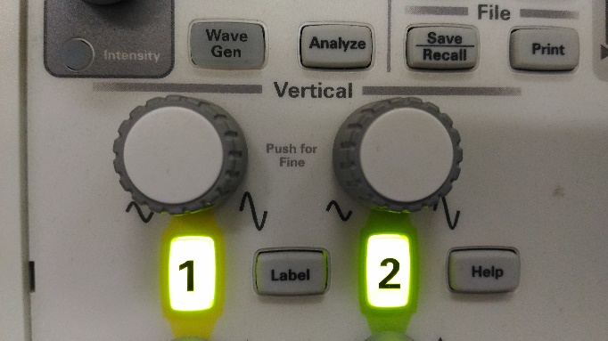

Figure 18

* Make sure both scales have the same value.
  + 1. Press “Acquire” -> “Acq. Mode” -> “High Resolution”. Then, use “Display” -> “Persistence” -> “∞” to saturate the curve on-screen.
    2. Attach a print with appropriate cursors measurements for calculation of the slope at the bottom of the slope (roughly 0%-10% of ). Use the numbers from the print to calculate it.

*Print: XY display with cursors, 0-10%*

|  |
| --- |
|  |

* + 1. Attach another print with appropriate cursors measurements for calculation of the slope at the top of the slope (roughly 90%-100% of ). Use the numbers from the print to calculate it.

*Print: XY display with cursors, 90%-100%*

|  |
| --- |
|  |

* + 1. Attach another print with cursors measuring the crossover distortion range.

*Print: XY display with cursors, dead-band*

|  |
| --- |
|  |

* + 1. Return to normal “Persistence” and “Acq. Mode” parameters.
    2. Turn the waveform generator off.
    3. Disconnect RX||RY and connect the resistor from section ‎2.1.
    4. Change the supply voltages back to **+/- 15V**, as in section ‎1.3.1.
    5. Turn the waveform generator back on and reset the signal to what it was before this (transfer function) section.
  1. Spectrum and THD measurement
     1. Display both input and output signals, and also the output’s spectrum, showing the first 5-10 harmonics. Attach a print which also shows the values of span and center that you chose. Then, attach another print with Vpp and frequency for the input signal, and Vpp and RMS for the output signal (total of 4 measurements).
* Always measure according to the “INFOBIT – How to measure a spectrum”! (see preliminary report section ‎13).

*Print: input, output, and output’s spectrum with span and center*

*Print: input, output, and output’s spectrum with measurements*

* + 1. Now use the cursors to correctly measure the harmonics of the output spectrum. Fill the table below to calculate the THD. Attach a print showing how you measure the difference between the first and second harmonics you measured for the table, showing the correct differences in height and in frequency.
    2. In the Excel table below, for each column, change “m” to the harmonic you measured.

*Print: input, output, and output’s spectrum, plus cursor measurements*

* For your convenience, the first harmonic is referenced as 0dB. Review the “INFOBIT – How to measure a spectrum “ document on the website, then fill the table below:



1. Output stage with biasing diodes

Refer to the preliminary report, section ‎8.

* 1. Disconnect the previous circuit.   
     If you loaded the previous circuit with RX, load this one with **RY**. Otherwise,  
     if you loaded the previous circuit with RY, load this one with **RX**.

Which resistor did you connect here?

|  |
| --- |
|  |

* 1. Connect an input signal: sine/1kHz, and choose its amplitude such that the **output** of the circuit measures **8Vpp**. Make sure the currents drawn from the power supplies are within the safety limit. What is the equivalent load resistor seen by this output stage? What is the input voltage you are using?

|  |
| --- |
|  |
|  |

* 1. Efficiency calculation
     1. Make the appropriate measurements as you see fit, and calculate .

|  |  |
| --- | --- |
| 5Ω resistor, right lead |  |
| 5Ω resistor, left lead |  |
|  | |

*Print: for calculating  (if deemed necessary)*

* + 1. Attach a print with Vpp and frequency for the input signal, and Vpp and RMS for the output signal (total of 4 measurements). Then, calculate the power dissipated on the load, .

*Print: input and output*

|  |
| --- |
|  |

* + 1. Using this input, attach a print with appropriate measurements and use it to calculate .

*Print: for calculating .*

* + 1. Calculate  and . Then find the efficiency of this stage, .

|  |
| --- |
|  |
|  |
|  |

* 1. Transfer function
     1. For this section only, switch to XY display and correctly display the circuit’s transfer function, . Attach a print with appropriate cursors measurements for calculation of the slope. Use the numbers from the print to calculate it.
* No need to change the load resistor or voltage supplies here!

*Print: XY display with cursors*

|  |
| --- |
|  |

* 1. Spectrum and THD measurement
     1. Display both input and output signals, and also the output’s spectrum, showing the first 5-10 harmonics. Attach a print with Vpp and frequency for the input signal, and Vpp and RMS for the output signal (total of 4 measurements).
* Always measure according to the “INFOBIT – How to measure a spectrum”! (see preliminary report section ‎13).

*Print: input, output, and output’s spectrum*

* + 1. Now use the cursors to correctly measure the harmonics of the output spectrum. Fill the table below to calculate the THD. Attach a print showing how you measure the difference between the first and second harmonics you measured for the table, showing the correct differences in height and in frequency.
    2. In the Excel table below, for each column, change “m” to the harmonic you measured.

*Print: input, output, and output’s spectrum, plus cursor measurements*



* 1. Recap

Review your measurements here and those of the previous circuit, section ‎2, and your preliminary report. What are the advantages of the current circuit over the previous one? (up to 5 lines for this answer)

|  |
| --- |
|  |
|  |
|  |
|  |
|  |

1. Output stage with biasing transistors

Refer to the preliminary report, section ‎9.

* 1. Disconnect the previous circuit.   
     If you loaded the previous circuit with RX, load this one with **RY**. Otherwise,  
     if you loaded the previous circuit with RY, load this one with **RX**.   
     Which resistor did you connect here?

|  |
| --- |
|  |

* 1. Connect an input signal: sine/1kHz, and choose its amplitude such that the **output** of the circuit measures **8Vpp**. Make sure the currents drawn from the power supplies are within the safety limit. What is the equivalent load resistor seen by this output stage? What is the input voltage you are using?

|  |
| --- |
|  |
|  |

* 1. Efficiency calculation

* + 1. Make the appropriate measurements as you see fit, and calculate .

|  |  |
| --- | --- |
| 5Ω resistor, right lead |  |
| 5Ω resistor, left lead |  |
|  | |

*Print: for calculating  (if deemed necessary)*

* + 1. Attach a print with Vpp and frequency for the input signal, and Vpp and RMS for the output signal (total of 4 measurements). Then, calculate the power dissipated on the load, .

*Print: input and output*

|  |
| --- |
|  |

* + 1. Using this input, attach a print with appropriate measurements and use it to calculate .

*Print: for calculating .*

* + 1. Calculate  and . Then find the efficiency of this stage, .

|  |
| --- |
|  |
|  |
|  |

* 1. Transfer function
     1. For this section only, switch to XY display and correctly display the circuit’s transfer function, . Attach a print with appropriate cursors measurements for calculation of the slope. Use the numbers from the print to calculate it.

*Print: XY display with cursors*

|  |
| --- |
|  |

* 1. Spectrum and THD measurement
     1. Display both input and output signals, and also the output’s spectrum, showing the first 5-10 harmonics. Attach a print with Vpp and frequency for the input signal, and Vpp and RMS for the output signal (total of 4 measurements).
* Always measure according to the “INFOBIT – How to measure a spectrum”! (see preliminary report section ‎13).

*Print: input, output, and output’s spectrum*

* + 1. Now use the cursors to correctly measure the harmonics of the output spectrum. Fill the table below to calculate the THD. Attach a print showing how you measure the difference between the first and second harmonics, showing the correct differences in height and in frequency.
    2. In the Excel table below, for each column, change “m” to the harmonic you measured.

*Print: input, output, and output’s spectrum, plus cursor measurements*



* 1. Input resistance
     1. For this section only, you will use a **compensated probe**. Get one yourself from the drawer down the corridor, or ask the lab instructor for one. Measure the *circuit’s* input (i.e. the waveform generator, “vg”, at TP29) in CH1 as usual, and use the compensated probe on CH2 to measure the *output stage’s* input (“vin”) (use the TP connected to the bases of the transistors).
* Observe the following images to understand how to connect the compensated probe instead of a BNC-BNC cable:

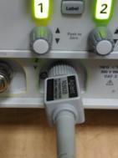 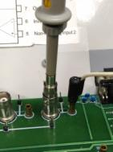

Figure 19

* On the scope press “2” for CH2 and on-screen under “probe” set the attenuation to 10:1.
* Now, measure as usual.

* + 1. Attach a print with Vpp, RMS, and frequency of CH1, and RMS of CH2 (total of 4 measurements). Then, use these measurements to calculate the input resistance, .

*Print: vg and vin*

|  |
| --- |
|  |

* + 1. Disconnect the compensated probe and return it to the drawer down the corridor. Make sure you reset CH2’s “probe attenuation” to 1:1 before you continue.
* That was a short encounter, but don’t worry! You will learn much more about the compensated probe in the next experiment.
  1. Recap

Review your measurements here and those of the previous circuit, section ‎3, and your preliminary report. What are the advantages of the current circuit over the previous one? (up to 5 lines for this answer)

|  |
| --- |
|  |
|  |
|  |
|  |
|  |

1. Output stage with feedback

Refer to the preliminary report, section ‎10.

* 1. Disconnect the previous circuit. Attach the same load resistor **as in the circuit from section ‎2**. Which resistor did you connect here?

|  |
| --- |
|  |

* 1. Connect an input signal: sine/1kHz, and choose its amplitude such that the **output** of the circuit measures **8Vpp**. Make sure the currents drawn from the power supplies are within the safety limit. What is the equivalent load resistor seen by this output stage? What is the input voltage you are using?

|  |
| --- |
|  |
|  |

* 1. Attach a print with Vpp and frequency for the input signal, and Vpp and RMS for the output signal (total of 4 measurements).

*Print: input and output*

In the following section, you will make some changes to the circuit which may results in supply currents higher than 80mA. For these sections (‎5.4 and its subsections) only, **make sure that the supply current does not exceed the safety limit of 160mA**.

Also, **make sure you shut down the board’s electricity between measurements, and do NOT leave the station unattended** (currents will rise as the transistors heat up!)**.**

* 1. Transfer function

For this section only, use the following steps IN THIS ORDER:  
 - Set the supply voltages to **+/- 5.0V.** - Set the waveform generator’s parameters to a sine/100Hz/8Vpp.  
 - Connect RX||RY as a load resistor.  
Switch to XY display (use the “HORIZ” button on the scope) and correctly display the circuit’s transfer function, .

* Before you continue, be sure to review section ‎2.4 – these sections are related!
* Remember to change to change the scales to match Figure 18.
  + 1. Attach a print with appropriate cursors measurements for calculation of the slope at the bottom of the slope (roughly 0%-10% of ). Use the numbers from the print to calculate it.

*Print: XY display with cursors, 0-10%*

|  |
| --- |
|  |

* + 1. Attach another print with appropriate cursors measurements for calculation of the slope at the top of the slope (roughly 90%-100% of ). Use the numbers from the print to calculate it.

*Print: XY display with cursors, 90%-100%*

|  |
| --- |
|  |

* + 1. Attach another print with cursors measuring the crossover distortion range.

*Print: XY display with cursors, dead-band*

|  |
| --- |
|  |

* + 1. Turn the waveform generator off.
    2. Disconnect RX||RY and connect the resistor from section ‎5.1.
    3. Change the supply voltages back to **+/- 15V**, as in section ‎1.3.1.
    4. Turn the waveform generator back on and reset the signal to what it was before this (transfer function) section.
  1. Recap

Review your measurements here and those of the circuit in section ‎2, and your preliminary report. What are the advantages of the current circuit over the previous one? (up to 5 lines for this answer)

|  |
| --- |
|  |
|  |
|  |
|  |
|  |

1. Output stage op-amp feedback

Refer to the preliminary report, section ‎11.

* 1. Disconnect the previous circuit. Do not connect RX or RY here.
  2. Connect an input signal: sine/1kHz, and choose its amplitude such that the **output** of the circuit measures **8Vpp**. Make sure the currents drawn from the power supplies are within the safety limit. What is the equivalent load resistor seen by this output stage? What is the input voltage you are using?

|  |
| --- |
|  |
|  |

* 1. Attach a print with Vpp and frequency for the input signal, and Vpp and RMS for the output signal (total of 4 measurements).

*Print: input and output*

* 1. Transfer function

For this section only, switch to XY display and correctly display the circuit’s transfer function, .

* No need to change the load resistor or voltage supplies here!
  + 1. Attach another print with cursors measuring the crossover distortion range.

*Print: XY display with cursors, dead-band*

|  |
| --- |
|  |

* 1. Spectrum and THD measurement
     1. Display both input and output signals, and also the output’s spectrum, showing the first 5-10 harmonics. Attach a print with Vpp and frequency for the input signal, and Vpp and RMS for the output signal (total of 4 measurements).
* Always measure according to the “INFOBIT – How to measure a spectrum”! (see preliminary report section ‎13).

*Print: input, output, and output’s spectrum*

* + 1. Now use the cursors to correctly measure the harmonics of the output spectrum. Fill the table below to calculate the THD. Attach a print showing how you measure the difference between the first and second harmonics you measured for the table, showing the correct differences in height and in frequency.
    2. In the Excel table below, for each column, change “m” to the harmonic you measured.

*Print: input, output, and output’s spectrum, plus cursor measurements*



* 1. Recap

Review your measurements here and those of the previous circuit, section ‎5, and your preliminary report. What are the advantages of the current circuit over the previous one? (up to 5 lines for this answer)

|  |
| --- |
|  |
|  |
|  |
|  |
|  |

1. Amplifier with output stage

Refer to the preliminary report, section ‎12.

* 1. Disconnect the previous circuit. First, set the waveform generator to a sine/10kHz/1mVpp. Do **not** connect the input signal to the circuit just yet!
  2. Connect RX to the output. What is the equivalent load resistor seen by this output stage?

|  |
| --- |
|  |

* 1. Preliminary DC measurements
     1. Use the multimeter to measure the voltage on R38 (use TP19). Write down the value and calculate the current mirrored by the current mirror. Justify approximations and assumptions.

|  |
| --- |
|  |
|  |
|  |

* + 1. Use the above to calculate (do **not** measure directly!) the dead-band width. Explain.

|  |
| --- |
|  |
|  |
|  |

* + 1. Estimate the minimal input voltage amplitude required so that an output signal begins to show. Refer to the preliminary report for help with formulas.

|  |
| --- |
|  |

* 1. Transfer function
     1. Connect the input signal, and **slowly (use 1mV steps)** change the input amplitude to a point where the **output** begins to show. Keep watching the power supply currents and make sure they are within the safety limit.
     2. Attach a print of the input and output (as a function of time), with Vpp and frequency for the input signal, and Vpp and RMS for the output signal (total of 4 measurements). What is the input voltage you are using?

*Print: input and output*

|  |
| --- |
|  |

* + 1. Now **slowly (use 10mV steps)** raise the input amplitude until the **output** reaches **1Vpp**. Keep watching the power supply currents and make sure they are within the safety limit.
    2. Attach another print with Vpp and frequency for the input signal, and Vpp and RMS for the output signal (total of 4 measurements). What is the input voltage you are using?

*Print: input and output*

|  |
| --- |
|  |

* + 1. Switch to XY display and correctly display the circuit’s transfer function, .
    2. Make sure you press “Acquire” -> “Acq. Mode” -> “Normal”.
* Review *“INFOBIT – The XY mode”* before continuing.
  + 1. Attach another print with cursors measuring the crossover distortion range. Does it fit your predictions?

*Print: XY display with cursors, dead-band, Normal mode*

|  |
| --- |
|  |
|  |

* + 1. Now press “Acquire” -> “Acq. Mode” -> “High Resolution”. Then, use “Display” -> “Persistence” -> “∞” to saturate the curve on-screen.
    2. Attach another print with cursors measuring the crossover distortion range. Explain what’s happening, and why is this print fundamentally different than the previous.

*Print: XY display with cursors, dead-band, High Resolution*

|  |
| --- |
|  |
|  |

* 1. Spectrum and THD measurement
     1. Display both input and output signals, and also the output’s spectrum, showing the first 5-10 harmonics. Attach a print with Vpp and frequency for the input signal, and Vpp and RMS for the output signal (total of 4 measurements).
* Always measure according to the “INFOBIT – How to measure a spectrum”! (see preliminary report section ‎13).

*Print: input, output, and output’s spectrum*

* + 1. Now use the cursors to correctly measure the harmonics of the output spectrum. Fill the table below to calculate the THD. Attach a print showing how you measure the difference between the first and second harmonics you measured for the table, showing the correct differences in height and in frequency.
    2. In the Excel table below, for each column, change “m” to the harmonic you measured.

*Print: input, output, and output’s spectrum, plus cursor measurements*



* 1. Conclusion

If you could change the output stage of this amplifier to any of the output stages you studied in this experiment, which would it be, and why? Explain. (up to 5 lines for this answer. Answer is not unique; you will be graded on the *discussion* you present here).

|  |
| --- |
|  |
|  |
|  |
|  |
|  |

**This concludes experiment #4.**

**You have reached to end of this experiment: ask the lab guide to write down the time.**

**Hand in the preliminary report, and present the complete preliminary report of the next experiment before starting it.**